**Handle windows popups using Selenium Webdriver**

There are many cases, where a application displays multiple windows when you open a website. Those are may be advertisements or may be a kind of information showing on popup windows. We can handle multiple windows using Windows Handlers in selenium webdriver.

**Step 1:** After opening the website, we need to get the main window handle by using driver.getWindowHandle();  
The window handle will be in a form of lengthy alpha numeric  
**Step 2:** We now need to get all the window handles by using driver.getWindowHandles();  
**Step 3:** We will compare all the window handles with the main Window handles and perform the operation the window which we need.

Click here to view Performing operations on multiple windows using reusable methods.  
The below example shows how to handle multiple windows and close all the child windows which are not need. We need to compare the main window handle to all the other window handles and close them.

**package** com.pack;

**import** java.util.Set;

**import** org.openqa.selenium.WebDriver;

**import** org.openqa.selenium.firefox.FirefoxDriver;

**import** org.testng.Assert;

**import** org.testng.annotations.Test;

**public** **class** **WindowExamples** {

**static** WebDriver driver;

@Test

**public** **void** **test_CloseAllWindowsExceptMainWindow**() {

driver = **new** FirefoxDriver();

*// It will open Naukri website with multiple windows*

driver.get("[http://www.naukri.com/"](http://www.naukri.com/));

*// To get the main window handle*

String windowTitle= getCurrentWindowTitle();

String mainWindow = getMainWindowHandle(driver);

Assert.assertTrue(closeAllOtherWindows(mainWindow));

Assert.assertTrue(windowTitle.contains("Jobs - Recruitment"), "Main window title is not matching");

}

**public** String **getMainWindowHandle**(WebDriver driver) {

**return** driver.getWindowHandle();

}

**public** String **getCurrentWindowTitle**() {

String windowTitle = driver.getTitle();

**return** windowTitle;

}

*//To close all the other windows except the main window.*

**public** **static** **boolean** **closeAllOtherWindows**(String openWindowHandle) {

Set allWindowHandles = driver.getWindowHandles();

**for** (String currentWindowHandle : allWindowHandles) {

**if** (!currentWindowHandle.equals(openWindowHandle)) {

driver.switchTo().window(currentWindowHandle);

driver.close();

}

}

driver.switchTo().window(openWindowHandle);

**if** (driver.getWindowHandles().size() == 1)

**return** **true**;

**else**

**return** **false**;

}

}

The below image will show you the multiple windows that open in the application. It has now open total of three windows (One is main window and other two are child windows)



The below image will show the multiple window handlers for child windows and main window. We will have all the window handles in one set and we use each of them to compare and perform operation on the required window.

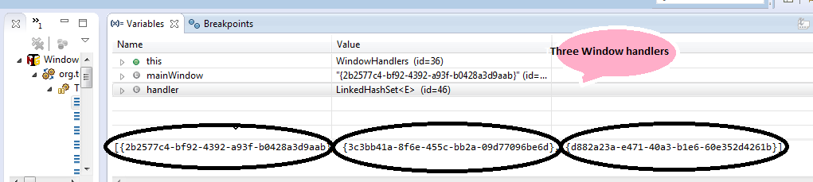

**The below is the output of the program:**  
{2b2577c4-bf92-4392-a93f-b0428a3d9aab}  
Naukri.com – Jobs – Jobs in India – Recruitment – Job Search – Employment – Job Vacancies  
it is the main window  
Naukri.com – Jobs – Jobs in India – Recruitment – Job Search – Employment – Job Vacancies  
Barclays  
Naukri.com – Jobs – Jobs in India – Recruitment – Job Search – Employment – Job Vacancies  
HCL  
Naukri.com – Jobs – Jobs in India – Recruitment – Job Search – Employment – Job Vacancies